TASK-12

**1) Create one vpc in N.virginia region.**

Created one vpc

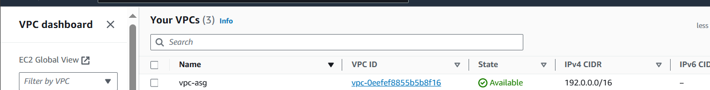

**2) Create two subnets.**

**One public subnet and one private subnet.** 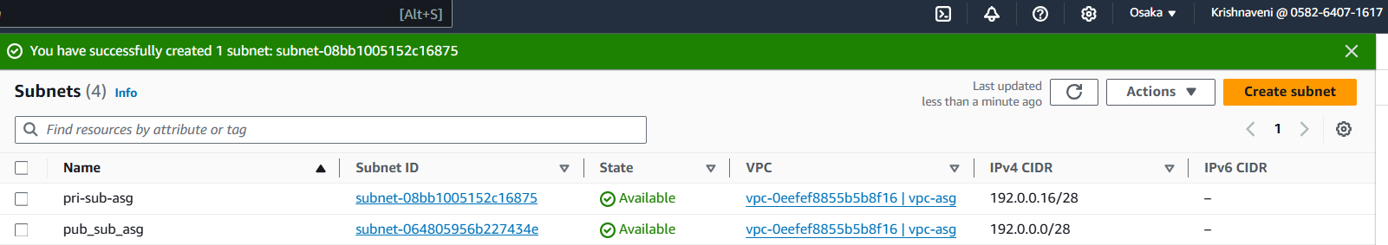

**3) Provide the IGW to the vpc.** 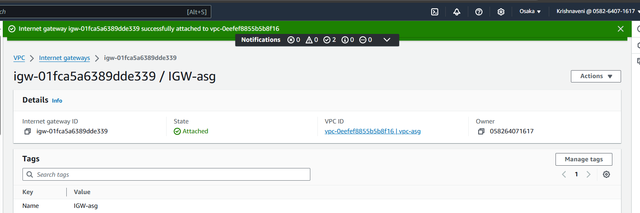

**4) Create One public RT and one private RT.**

Public routetable

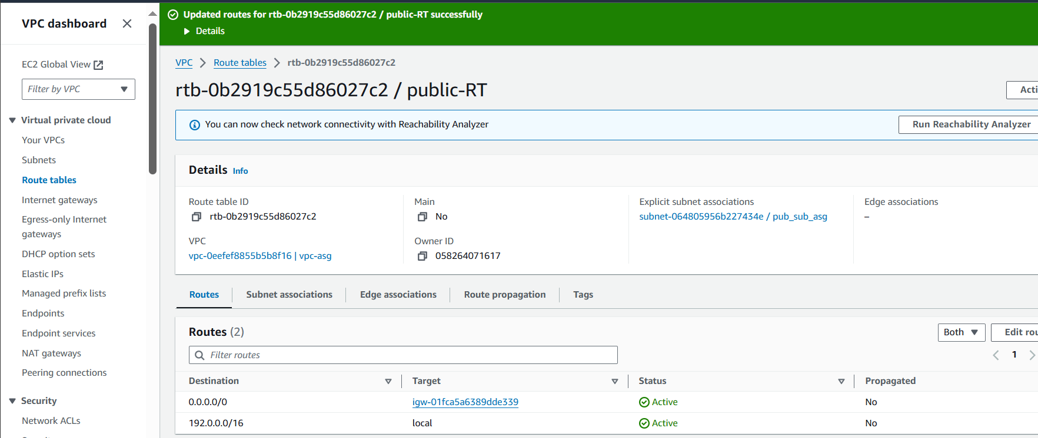

Private Routetable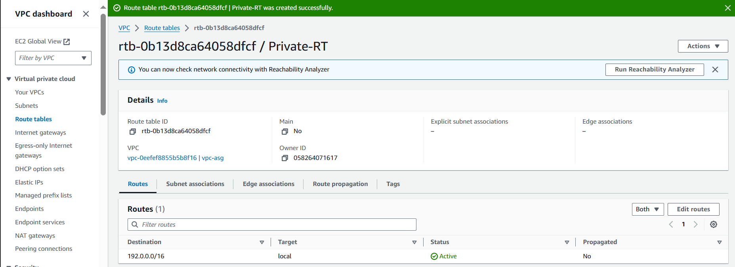

**5) Deploy NAT gateway on public subnet and attach the NAT gatewat to private subnet.**

Created NAT gateway in PUBLIC subnet 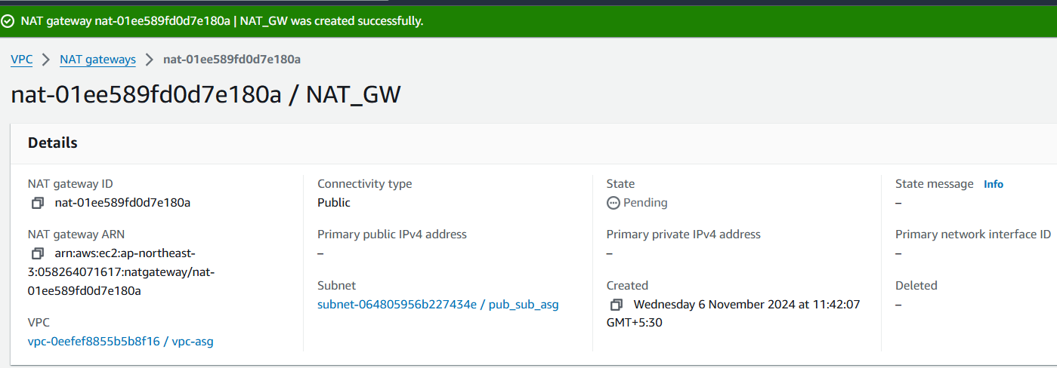

Added NAT gateway in the private subnet

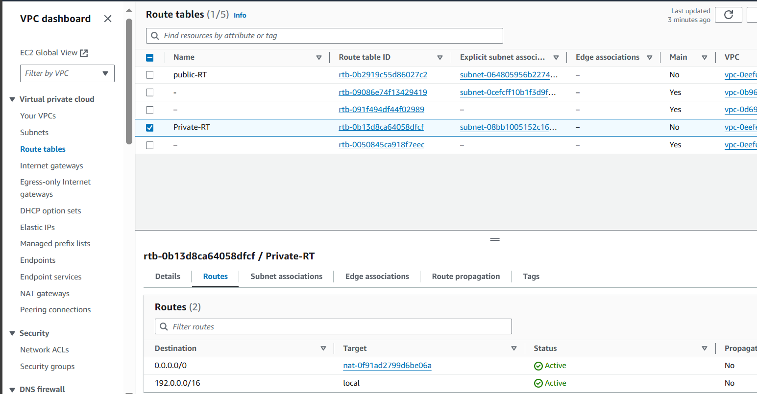

**6) Create Two instances,one in public subnet and one in private subnet.**

Created one instance in public subnet

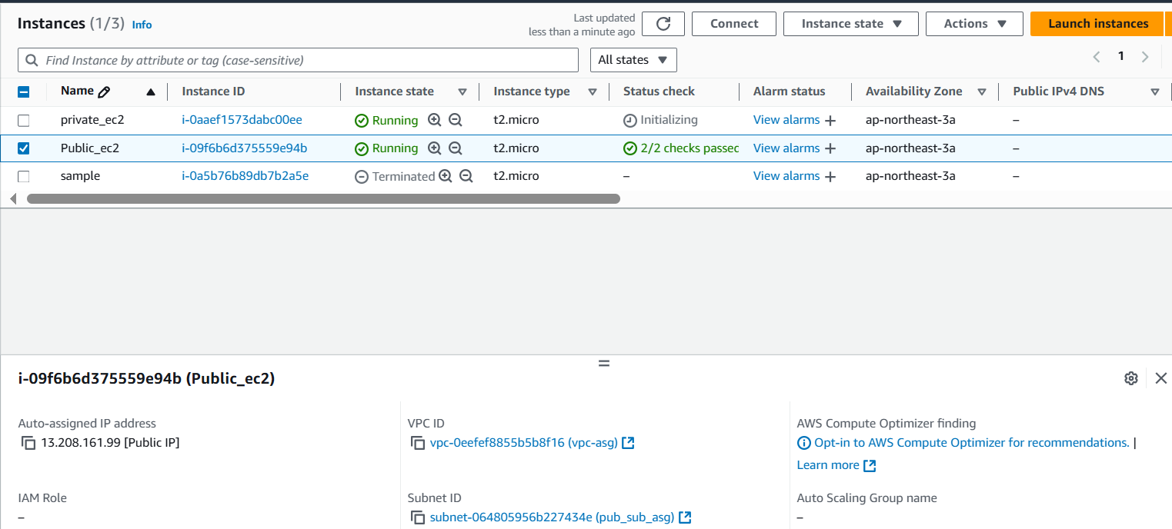

Created one instance in private subnet

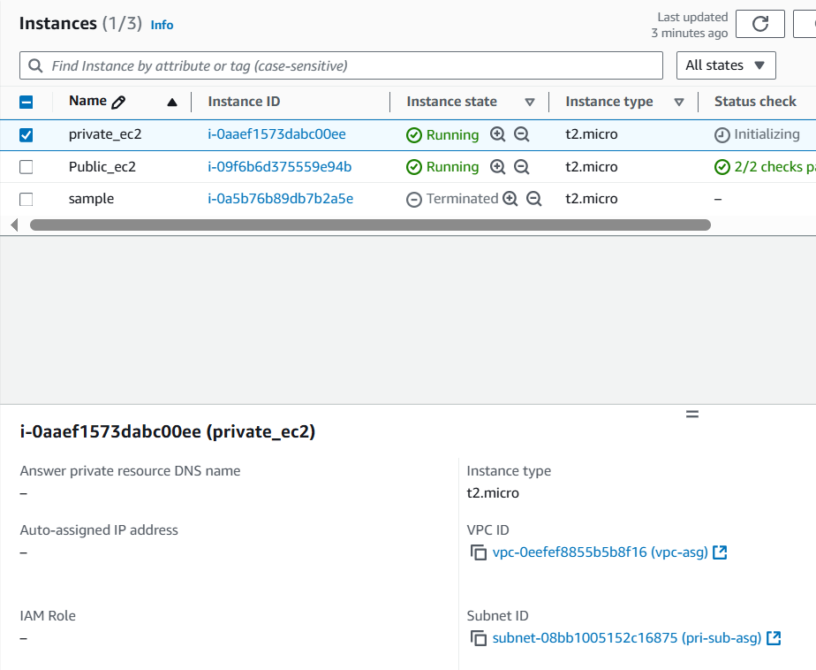

**7) Deploy Apache server on both the ec2 instances with sample index.html file.**

Public-ec2

Connecting to the remote server 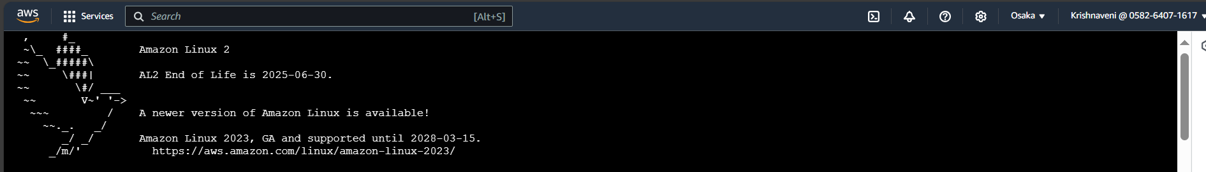

Installing the apache(httpd) 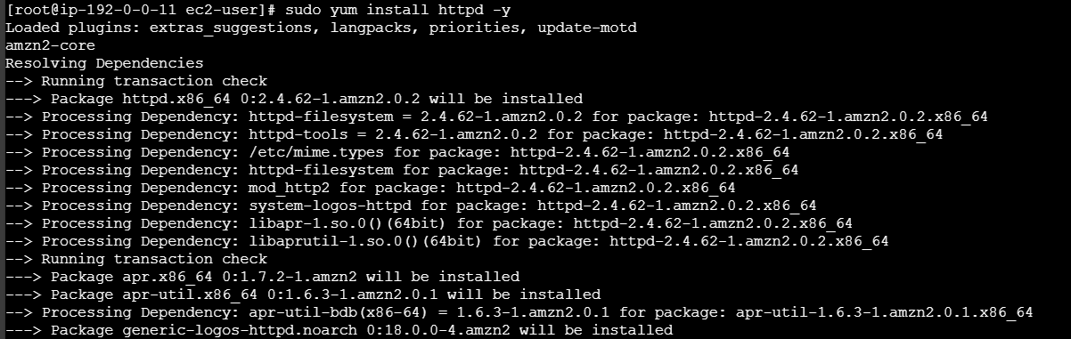

Starting the service using systemctl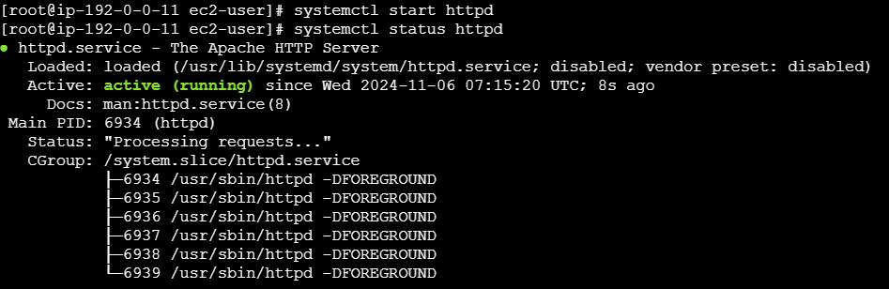

Checking the output in the browser

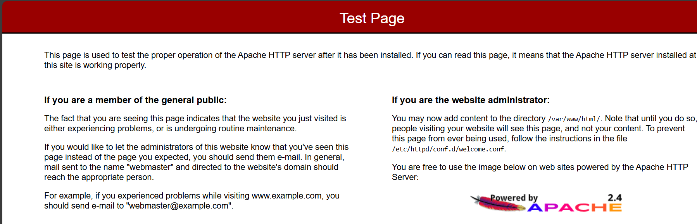

Deploying one index.html file



Output:

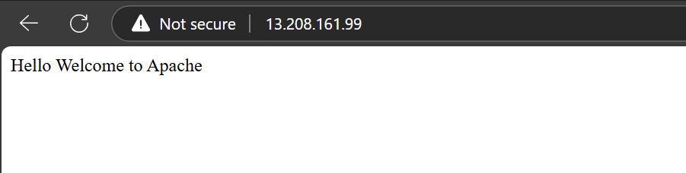

Private-ec2

Connected to private ec2 [Bastian/jump down server]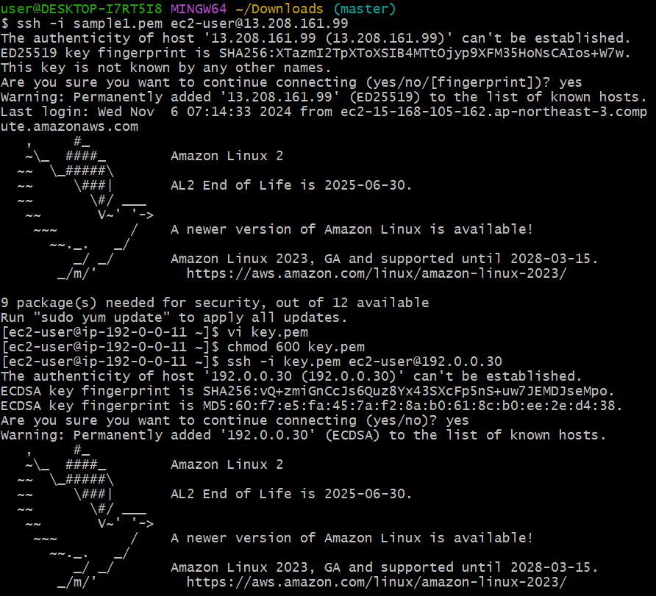

Installing httpd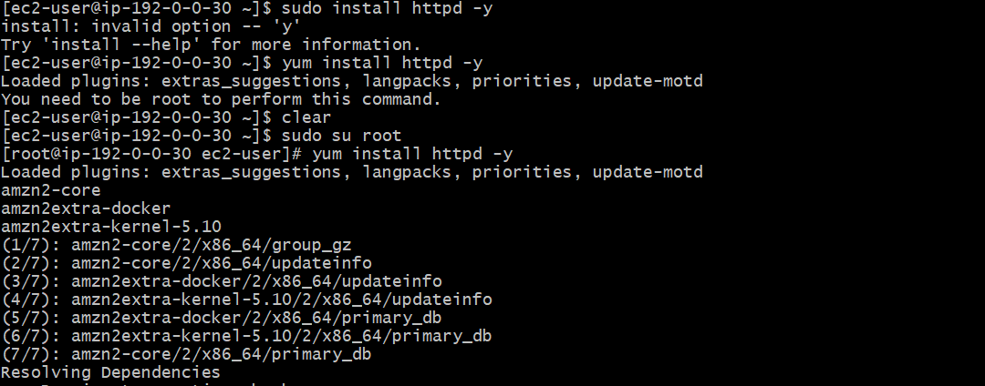 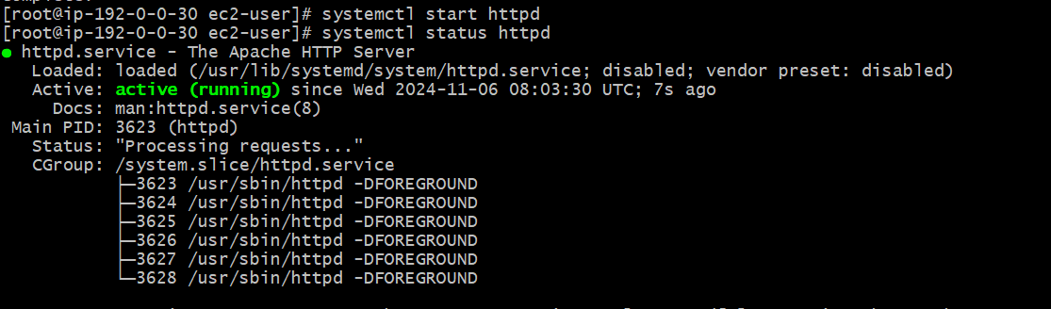 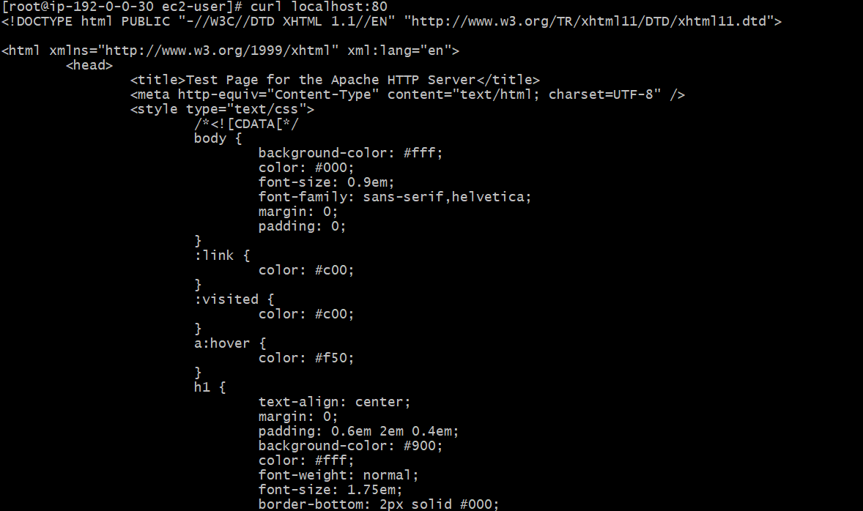

Deploying index.html in priivate ec2

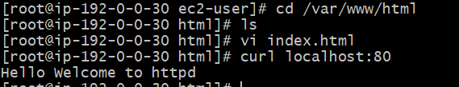

**8) Create one application load balancer and attach the load balancer to both the ec2 instances.**

**C**reating one application loadbalancer which has targetgroup attched

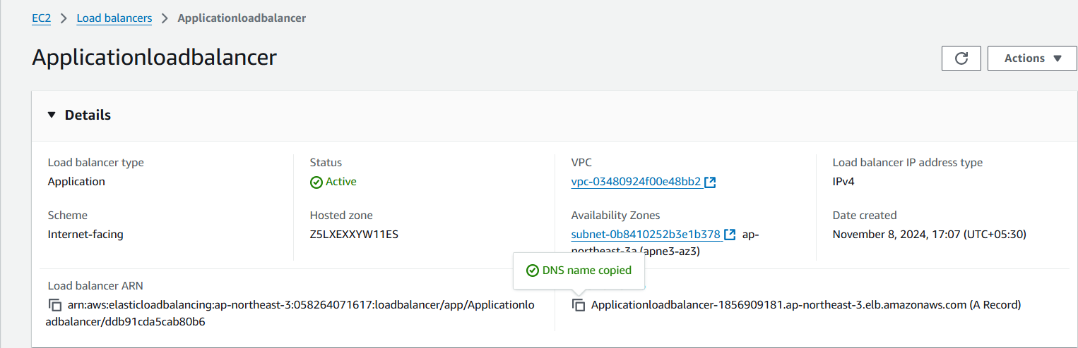

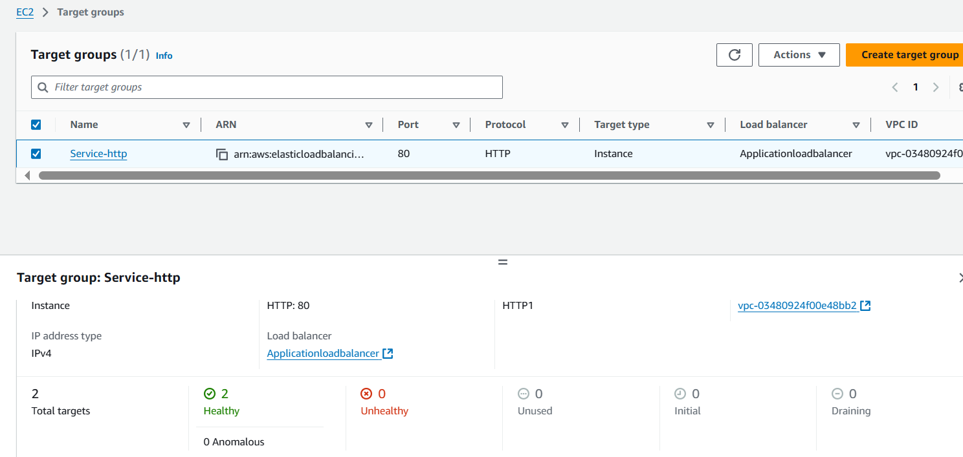

We can copy the dns name in the loadbalancer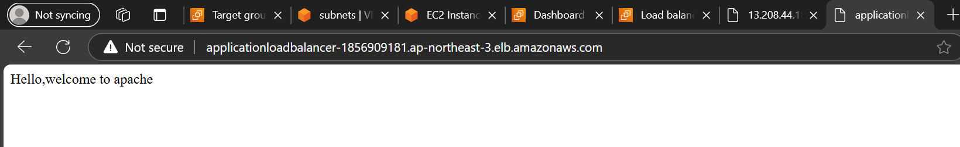

Refreshing the browser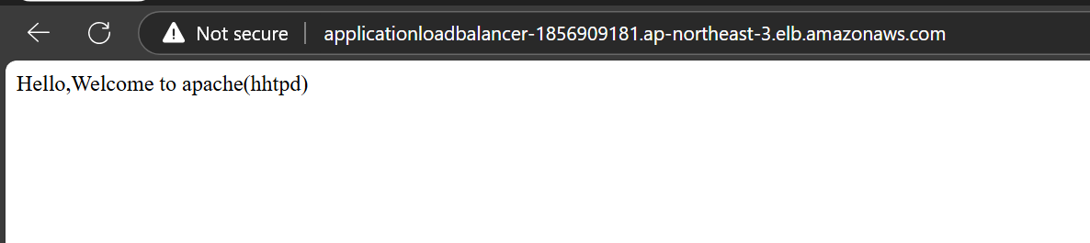

**9) Store Application load balancer logs to s3.**

Go to the loadbalancer>Attributes>access logs

Create one s3 bucket with policy attached

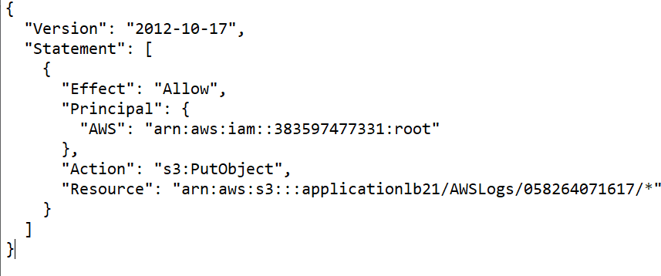

Accessing logs

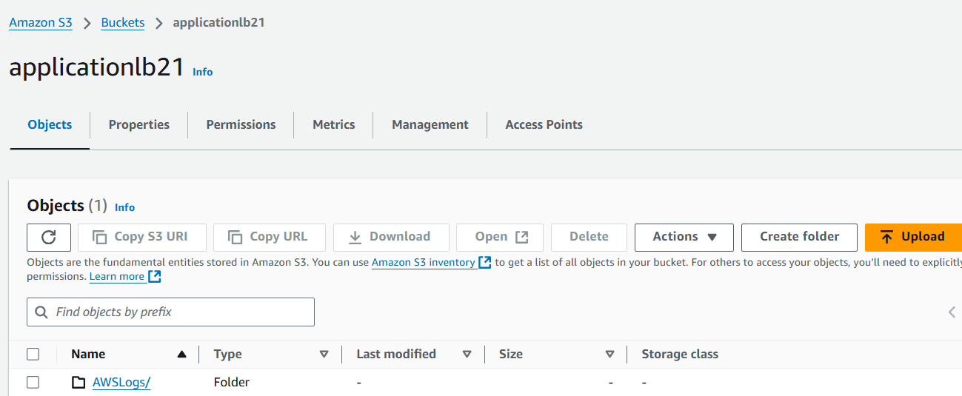

We can view the logs

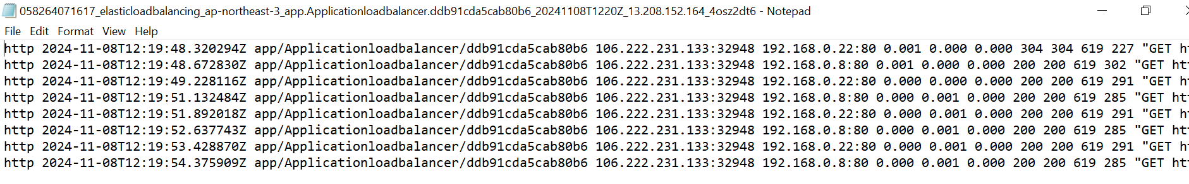

**10) Store the vpc flow logs to cloudwtach group.**

Created a VPC flowlog in the cloudwatch destination

Also created cloudwatch for destination 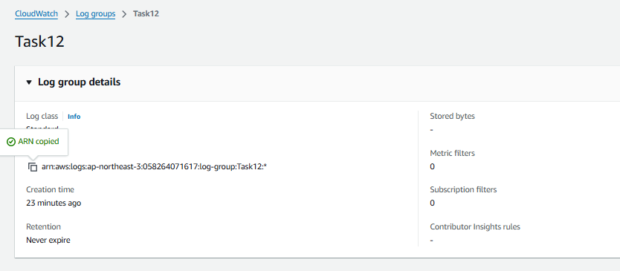

Created IAM ROLE 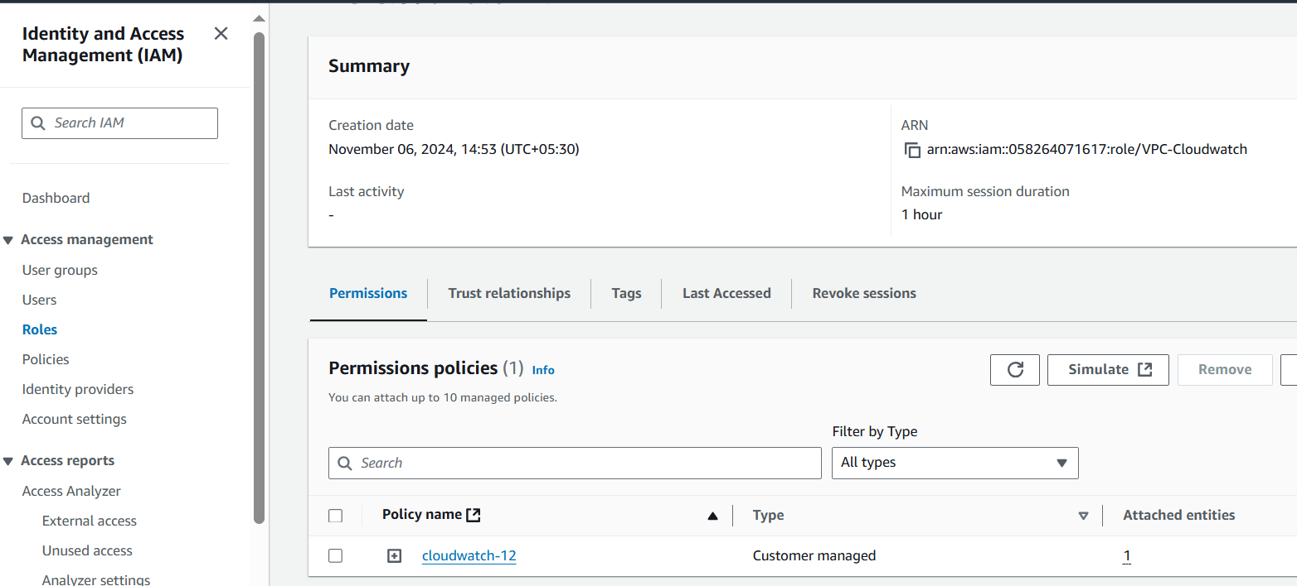

We can check that in VPC flowlog

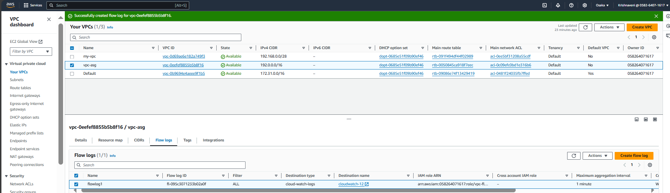

Destination:cloudwatch

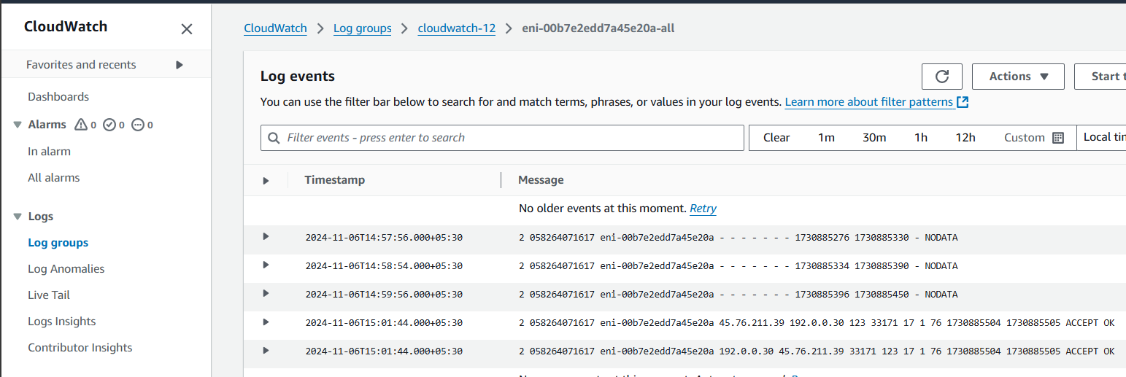

**11) Create Monitoring Dashboards to monitor cpu utilization and to monitor apache service.**

Created an ec2

Installed httpd service

Started the service

NEXT,Go to cloudwatch

Select Dashboards>Name>metric:Number>

Metric:select ec2>search for the created ec2>choose CPUUtilization>create

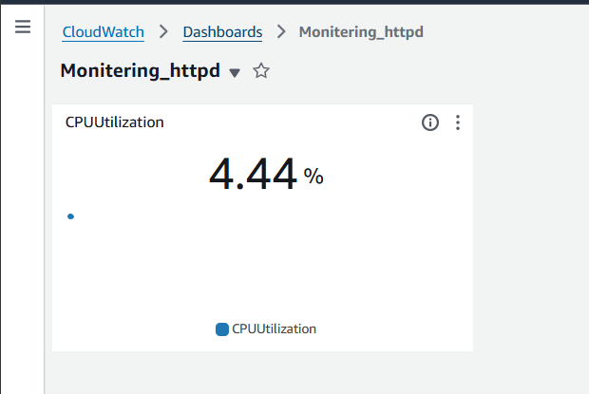

**12) CPU utilizationis more than 70% then it should triggere Autoscaling and launch new instance.**

Steps:

Created one template

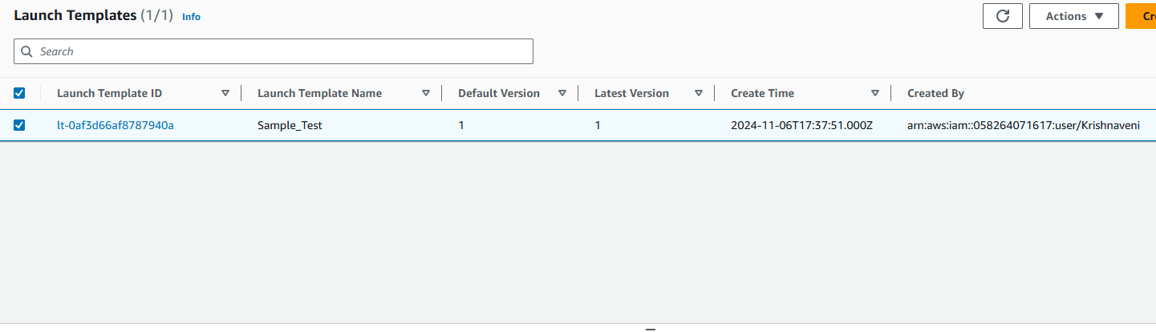

**Created autoscaling group**

**In which I provided target value for cpu utilization**

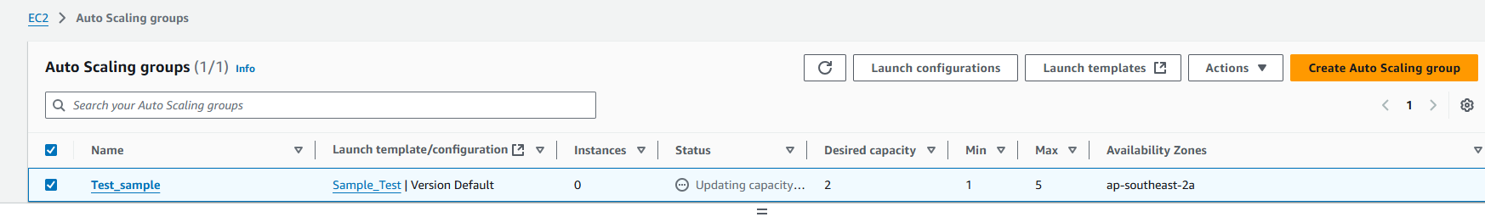

**2-instances launched**

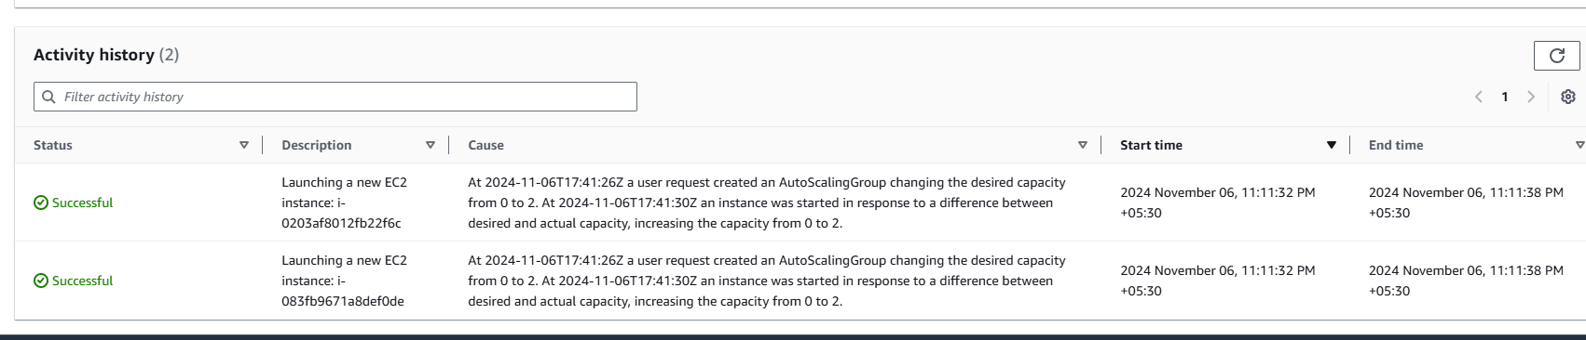

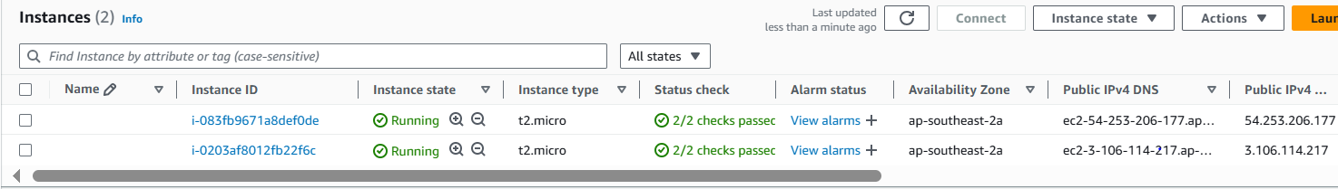

**Adding load to increase the cpu utilization**

**As we increased load new instances were launced**

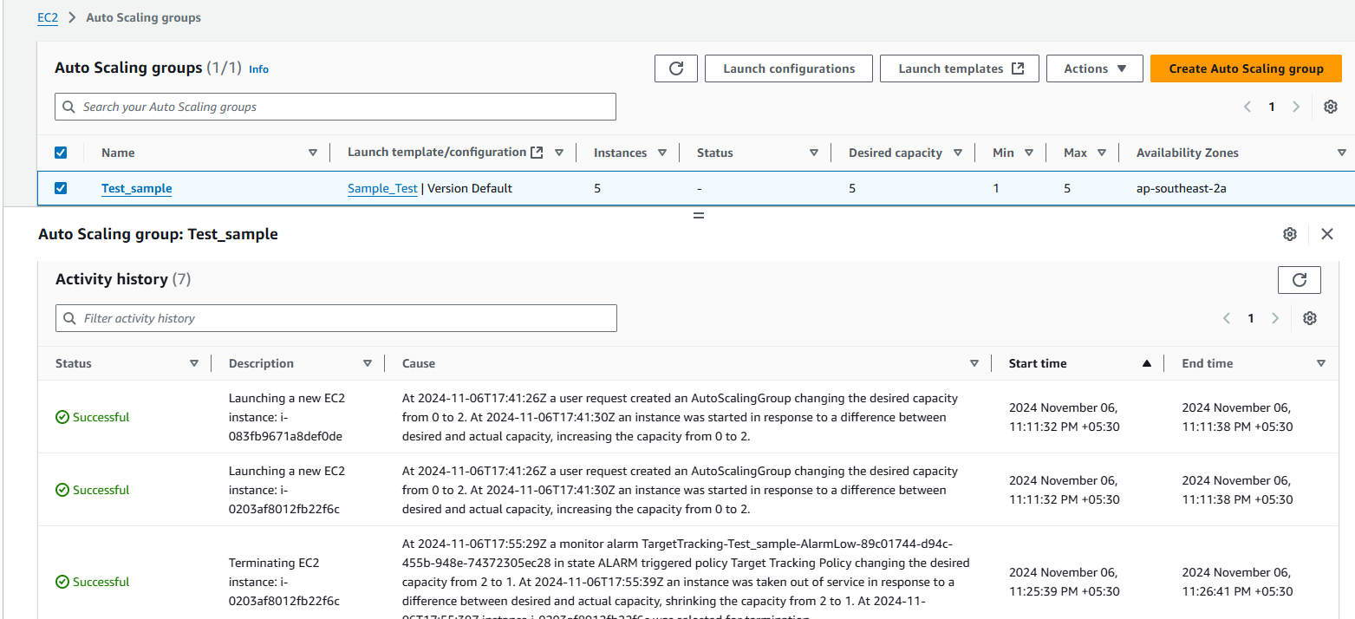

**We can check in the instances also**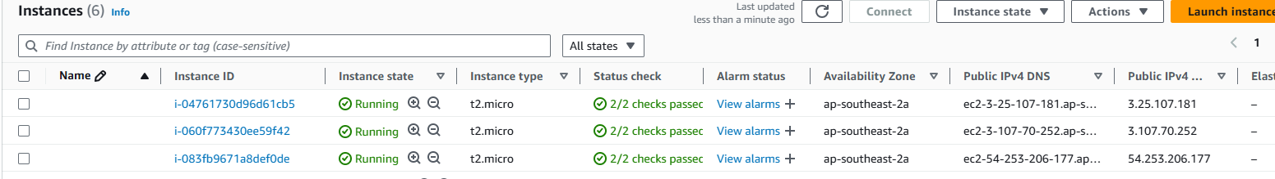

**New instances has launced**